Nativity Worships
Easter Day
Sunday, April 9, 2023

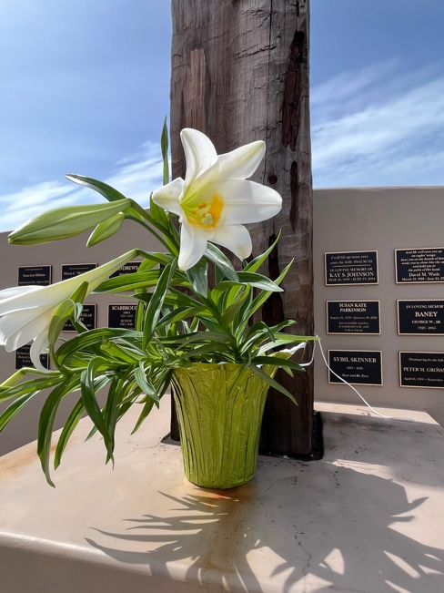
The Rev. Kirsten Snow Spalding, Rector
The Rev. Rebecca Morehouse, Deacon
The Rev. Scott Gambrill Sinclair, Priest in Residence
The Rev. Lynn Oldham Robinett, Assisting Priest

333 Ellen Dr.
San Rafael, CA 94903
www.nativityonthehil.org
415-479-7023
nativityonthehill@gmail.com
The Word of God

Entrance Rite

Prelude Reverie for Horn and Piano by Alexandre Glazounow
Performed by Janis Lieberman, Horn and Dylan Snodgrass, Piano
The people sit in quiet contemplation preparing for worship. Children are welcome to get a book or crayons from the back of the church and sit with their parents or at the table in the back of the sanctuary..

Entrance Hymn Jesus Christ is risen today (Easter Hymn) (H 207)
All stand to sing the processional hymn. It is customary to reverence the cross as it passes your row.
Opening Acclamation
The people standing, the Presider says
Presider | Alleluia. Christ is risen.
People | The Lord is risen indeed. Alleluia.

Collect for Purity
The Presider may say
Almighty God, to you all hearts are open, all desires known, and from you no secrets are hid: Cleanse the thoughts of our hearts by the inspiration of your Holy Spirit, that we may perfectly love you, and worthily magnify your holy Name; through Christ our Lord. Amen.

Hymn of Praise Lo, the fair beauty of earth [Hail thee, festival day!] (Salve festa dies) (H 175)
The people remain standing.
The Collect of the Day
Presider | The Lord be with you.
People | And also with you.
Presider | Let us pray.

O God, who for our redemption gave your only-begotten Son to the death of the cross, and by his glorious resurrection delivered us from the power of our enemy: Grant us so to die daily to sin, that we may evermore live with him in the joy of his resurrection; through Jesus Christ your Son our Lord, who lives and reigns with you and the Holy Spirit, one God, now and for ever. Amen.

The Lessons

First Reading: Acts 10:34-43
The people sit.
A Reading from the Acts of the Apostles.
³⁴Peter began to speak to [Cornelius and the other Gentiles]: “I truly understand that God shows no partiality, ³⁵but in every nation anyone who fears him and does what is right is acceptable to him. ³⁶You know the message he sent to the people of Israel, preaching peace by Jesus Christ—he is Lord of all. ³⁷That message spread throughout Judea, beginning in Galilee after the baptism that John announced: ³⁸how God anointed Jesus of Nazareth with the Holy Spirit and with power; how he went about doing good and healing all who were oppressed by the devil, for God was with him. ³⁹We are witnesses to all that he did both in Judea and in Jerusalem. They put him to death by hanging him on a tree; ⁴⁰but God raised him on the third day and allowed him to appear, ⁴¹not to all the people but to us who were chosen by God as witnesses, and who ate and drank with him after he rose from the dead. ⁴²He commanded us to preach to the people and to testify that he is the one ordained by God as judge of the living and the dead. ⁴³All the prophets testify about him that everyone who believes in him receives forgiveness of sins through his name.”

Reader | The Word of the Lord.
People | Thanks be to God.

Silence may follow.

Psalm: Psalm 118:1-2, 14-24
Remain seated.
¹Give thanks to the Lord, for he is good; *
his mercy endures for ever.
²Let Israel now proclaim, *
“His mercy endures for ever.”
¹⁴The Lord is my strength and my song, *
and he has become my salvation.
¹⁵There is a sound of exultation and victory *
in the tents of the righteous:
¹⁶“The right hand of the Lord has triumphed! *
The right hand of the Lord is exalted!
The right hand of the Lord has triumphed!”
¹⁷I shall not die, but live, *
and declare the works of the Lord.
¹⁸The Lord has punished me sorely, *
but he did not hand me over to death.
¹⁹Open for me the gates of righteousness; *
I will enter them;
I will offer thanks to the Lord.
²⁰“This is the gate of the Lord; *
he who is righteous may enter.”
²¹I will give thanks to you, for you answered me *
and have become my salvation.
²²The same stone which the builders rejected *
has become the chief cornerstone.
²³This is the Lord’s doing, *
and it is marvelous in our eyes.
²⁴On this day the Lord has acted; *
we will rejoice and be glad in it.

Second Reading: Colossians 3:1-4
The people sit.
A Reading from Paul's letter to the Church in Colossus.
¹[Since] you have been raised with Christ, seek the things that are above, where Christ is, seated at the right hand of God.²Set your minds on things that are above, not on things that are on earth, ³for you have died, and your life is hidden with Christ in God. ⁴When Christ who is your life is revealed, then you also will be revealed with him in glory.

Reader | The Word of the Lord.
People | Thanks be to God.

Silence may follow.

Sequence Hymn He is risen, he is risen (Unser Herrscher) (H 180)
All stand.

Gospel Alleluia Alleluia and verses (Hooker) (Gelobt sei Gott) (WLP 848)

Gospel: John 20:1-18
All stand.
Deacon | The Holy Gospel of our Lord Jesus Christ according to John.
People | Glory to you, Lord Christ.

¹Early on the first day of the week, while it was still dark, Mary Magdalene came to the tomb and saw that the stone had been removed from the tomb. ²So she ran and went to Simon Peter and the other disciple, the one whom Jesus loved, and said to them, “They have taken the Lord out of the tomb, and we do not know where they have laid him.” ³Then Peter and the other disciple set out and went toward the tomb. ⁴The two were running together, but the other disciple outran Peter and reached the tomb first. ⁵He bent down to look in and saw the linen wrappings lying there, but he did not go in. ⁶Then Simon Peter came, following him, and went into the tomb. He saw the linen wrappings lying there, ⁷and the cloth that had been on Jesus’ head, not lying with the linen wrappings but rolled up in a place by itself. ⁸Then the other disciple, who reached the tomb first, also went in, and he saw and believed; ⁹for as yet they did not understand the scripture, that he must rise from the dead. ¹⁰Then the disciples returned to their homes.
¹¹But Mary stood weeping outside the tomb. As she wept, she bent over to look into the tomb; ¹²and she saw two angels in white, sitting where the body of Jesus had been lying, one at the head and the other at the feet. ¹³They said to her, “Woman, why are you weeping?” She said to them, “They have taken away my Lord, and I do not know where they have laid him.” ¹⁴When she had said this, she turned around and saw Jesus standing there, but she did not know that it was Jesus. ¹⁵Jesus said to her, “Woman, why are you weeping? Whom are you looking for?” Supposing him to be the gardener, she said to him, “Sir, if you have carried him away, tell me where you have laid him, and I will take him away.” ¹⁶Jesus said to her, “Mary!” She turned and said to him in Hebrew, “Rabbouni!” (which means Teacher). ¹⁷Jesus said to her, “Do not hold on to me, because I have not yet ascended to the Father. But go to my brothers and say to them, ‘I am ascending to my Father and your Father, to my God and your God.’ ” ¹⁸Mary Magdalene went and announced to the disciples, “I have seen the Lord”; and she told them that he had said these things to her.

Deacon | The Gospel of the Lord.
People | Praise to you, Lord Christ.

Gospel Alleluia
The Gospel Alleluia from above is repeated once without a verse.

The Sermon The Rev. Kirsten Snow Spalding

Sermon HYMN
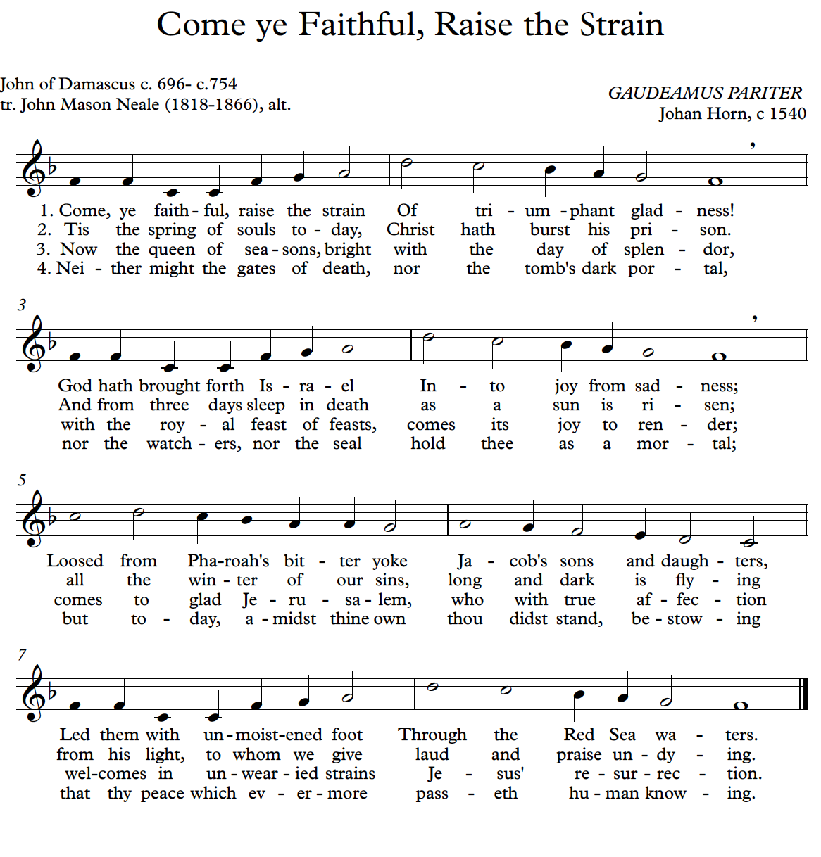
The Creed
All remain standing.
We believe in one God,
the Father, the Almighty,
maker of heaven and earth,
of all that is, seen and unseen.
We believe in one Lord, Jesus Christ,
the only Son of God,
eternally begotten of the Father,
God from God, Light from Light,
true God from true God,
begotten, not made,
of one Being with the Father.
Through him all things were made.
For us and for our salvation
he came down from heaven:
by the power of the Holy Spirit
he became incarnate from the Virgin Mary,
and was made man.
For our sake he was crucified under Pontius Pilate;
he suffered death and was buried.
On the third day he rose again
in accordance with the Scriptures;
he ascended into heaven
and is seated at the right hand of the Father.
He will come again in glory to judge the living and the dead,
and his kingdom will have no end.
We believe in the Holy Spirit, the Lord, the giver of life,
who proceeds from the Father and the Son.
With the Father and the Son he is worshiped and glorified.
He has spoken through the Prophets.
We believe in one holy catholic and apostolic Church.
We acknowledge one baptism for the forgiveness of sins.
We look for the resurrection of the dead,
and the life of the world to come. Amen

The Prayers of the People
All remain standing.
In peace, we pray to you, Lord God.
Silence
For all people in their daily life and work;
For our families, friends, and neighbors, and for those who are alone.
For this community, the nation, and the world;
For all who work for justice, freedom, and peace.
For the just and proper use of your creation;
For the victims of hunger, fear, injustice, and oppression.
For all who are in danger, sorrow, or any kind of trouble;
For those who minister to the sick, the friendless, and the needy.
For the peace and unity of the Church of God;
For all who proclaim the Gospel, and all who seek the Truth.
For Michael. our Presiding Bishop, and Marc our Bishop; and for all bishops and other ministers;
For all who serve God in his Church.
For the special needs and concerns of this congregation remembering especially those on our parish prayer list: Jamie, Nancy B and Nancy C, Marge, Donna, Dan, Nina A, Marian, Steve, Norma, and Jane; our friends and family: John, Niles, Diedre, Mary Lou, Seanna, Kevin, Nancy Jane, Walter, Les, Jeannie, Lisa, Bill, Hudson, Steve, Kathy W, Kamla, Joan and Scott;
and those who have died: Zachary York, Will Gutterman, Nancy Jane Rhea, those who have died in the war in Ukraine, and those who have died as a result of gun violence,

Silence
The People may add their own petitions
Hear us, Lord;
For your mercy is great.
We thank you, Lord, for all the blessings of this life.
Silence
The People may add their own thanksgivings
We will exalt you, O God our King;
And praise your Name for ever and ever.
We pray for all who have died, that they may have a place in your eternal kingdom.
Silence
The People may add their own petitions
Lord, let your loving-kindness be upon them;
Who put their trust in you.
We pray to you also for the forgiveness of our sins.
Silence may be kept.
Leader and People
Have mercy upon us, most merciful Father;
in your compassion forgive us our sins,
known and unknown,
things done and left undone;
and so uphold us by your Spirit
that we may live and serve you in newness of life,
to the honor and glory of your Name;
through Jesus Christ our Lord. Amen.
The Presider concludes with an absolution or a suitable Collect.

The Peace
All stand.
Presider | The peace of Christ be always with you.
People | And also with you.

Then the Ministers and the People may greet one another in the name of the Lord.
ANNOUNCEMENTS

We are delighted that you are with us today. If you would like to speak with a member of the clergy, or would like to be added to our mailing list please leave your name on the clipboard at the back of the church, speak to an usher, or send a note to nativityonthehill@gmail.com.

After our worship, there will be an Easter Egg hunt for all children. The hidden eggs contain both coins and sweets. The coins will be gathered as a donation for the Bay View Mission which will provide fresh eggs to neighbors in need.

Please join us for a festive Easter Brunch hosted by Nativity clergy on the patio, everyone is welcome.

The Holy Communion

Offertory Sentence
The Presider says
O Lord our God, you are worthy to receive glory and honor and power; because you have created all things, and by your will they were created and have their being. Revelation 4:11

CHOIR Troparia

Troparia (pl. of Troparion) are chants from the Byzantine tradition, beginning in the 5th Cent. They are liturgical but not scriptural, and originally used to add commentary or depth to scriptural sections of the liturgy. The choir is singing Troparia by Alex. Roznov written in the late 19th C.; followed by an Arabic melody Troparion, harmonized in the early 20th C., a “Skoriye” (or “very fast”) Russian version, and finally, one from Serbia, Then, we will all sing together the same text, set to early American melody. In whatever form or language we care to announce it: Christ is Risen!

Troparion Christ is risen from the dead (Early American) (WLP 817)

The Great Thanksgiving

Sursum Corda
The People remain standing.

Proper Preface
Presider | It is truly right, and good and joyful, to give you thanks, all-holy God, source of life and fountain of mercy.

But chiefly are we bound to praise you for the glorious resurrection of your Son Jesus Christ our Lord; for he is the true Paschal Lamb, who was sacrificed for us, and has taken away the sin of the world. By his death he has destroyed death, and by his rising to life again he has won for us everlasting life.
Therefore, joining with Angels and Archangels and with the faithful of every generation, we lift our voices with all creation as we sing (say):

Sanctus Holy, holy, holy (Schubert/Proulx) (S 130)
Words of Institution
The Presider continues
Blessed are you, gracious God,
creator of the universe and giver of life.
You formed us in your own image
and called us to dwell in your infinite love.
You gave the world into our care
that we might be your faithful stewards
and show forth your bountiful grace.
But we failed to honor your image
in one another and in ourselves;
we would not see your goodness in the world around us;
and so we violated your creation,
abused one another,
and rejected your love.
Yet you never ceased to care for us,
and prepared the way of salvation for all people.
Through Abraham and Sarah
you called us into covenant with you.
You delivered us from slavery,
sustained us in the wilderness,
and raised up prophets
to renew your promise of salvation.
Then, in the fullness of time,
you sent your eternal Word,
made mortal flesh in Jesus.
Born into the human family,
and dwelling among us,
he revealed your glory.
Giving himself freely to death on the cross,
he triumphed over evil,
opening the way of freedom and life.
On the night before he died for us,
Our Savior Jesus Christ took bread,
and when he had given thanks to you,
he broke it, and gave it to his friends, and said:
“Take, eat:
This is my Body which is given for you.
Do this for the remembrance of me.”
As supper was ending, Jesus took the cup of wine,
and when he had given thanks,
he gave it to them, and said:
“Drink this, all of you:
This is my Blood of the new Covenant,
which is poured out for you and for all
for the forgiveness of sins.
Whenever you drink it,
do this for the remembrance of me.”
Therefore we proclaim the mystery of faith:
Presider and People
Christ has died.
Christ is risen.
Christ will come again.

The Presider continues
Remembering his death and resurrection,
we now present to you from your creation
this bread and this wine.
By your Holy Spirit may they be for us
the Body and Blood of our Savior Jesus Christ.
Grant that we who share these gifts
may be filled with the Holy Spirit
and live as Christ’s Body in the world.
Bring us into the everlasting heritage
of your daughters and sons,
that with [__________ and] all your saints,
past, present, and yet to come,
we may praise your Name for ever.
Through Christ and with Christ and in Christ, in the unity of the Holy spirit, to you be honor, glory and praise, for ever and ever.

The Lord’s Prayer
As our Savior Christ has taught us, we now pray,
People and Presider
Our Father in heaven,
hallowed be your Name,
your kingdom come,
your will be done, on earth as in heaven.
Give us today our daily bread.
Forgive us our sins
as we forgive those who sin against us.
Save us from the time of trial
and deliver us from evil.
For the kingdom, the power,
and the glory are yours,
now and forever. Amen.

The Breaking of the Bread

Fraction Anthem Jesus, Lamb of God (Schubert/Proulx) (S 164)
Invitation
The Presider says
The Gifts of God for the People of God.

Distribution
The ministers receive the Sacrament in both kinds, and then immediately deliver it to the people.
The Bread and the Cup are given to the communicants with these words
The Body (Blood) of our Lord Jesus Christ keep you in everlasting life. [Amen.]
All people are welcome to receive Communion by coming forward and receiving bread in your outstretched hands and wine from the common cup. If you would like a blessing, please approach the priest with hands crossed at your chest. If you do not wish to drink, you may cross your hands after taking the bread and just hear the words and observe the cup. If you prefer to receive communion at your seat, please let an usher know and we will bring communion to you.

Communion Hymn O wheat whose crushing was for bread (New Life) (WLP 760)

Post-Communion Prayer
After Communion, the Presider says
Let us pray.
Presider and People
Eternal God, heavenly Father,
you have graciously accepted us as living members
of your Son our Savior Jesus Christ,
and you have fed us with spiritual food
in the Sacrament of his Body and Blood.
Send us now into the world in peace,
and grant us strength and courage
to love and serve you
with gladness and singleness of heart;
through Christ our Lord. Amen.

Blessing
The Priest blesses the people, saying
The blessing of God Almighty, the Father, the Son, and the Holy Spirit, be upon you and remain with you for ever. Amen.

Post-Communion Hymn This joyful Eastertide (Vruechten) (H 192)

The Choir will sing the verses and the congregation is invited to join in the refrain:

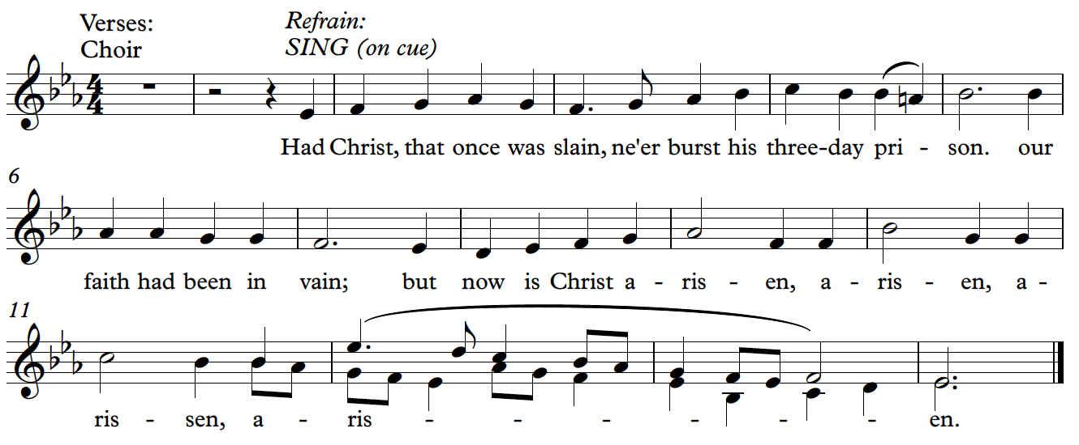

Dismissal
 | Let us go forth in the name of Christ. Alleluia, alleluia.
People | Thanks be to God. Alleluia, alleluia.

POStlude Allegro for Horn and Piano by Mozart
Performed by Janis Lieberman, Horn and Dylan Snodgrass, Organ

From riteplanning.com.
Copyright © 2023 Church Publishing Inc. All rights reserved.

Easter Altar Flowers were given to the Glory of God by

Ruth Baney
Nina Woods
Kim Bromley
Susan Pick
Kathy Schlegel
T’sa Hammond
Nancy Chapman
Duane Johnson
Katy Kenney
Rebecca Morehouse

Our beautiful outdoor gardens are maintained by volunteers, with special thanks to Elizabeth Buskirk who prunes and weeds.

