Nativity Worships
Easter Season 2024

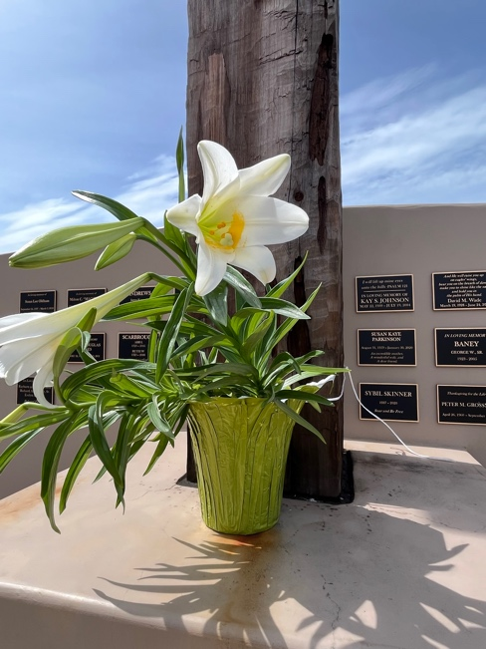

The Very Rev. Kirsten Snow Spalding, Rector
The Rev. Rebecca Morehouse, Deacon
The Rev. Scott Gambrill Sinclair, Priest in Residence
The Rev. Lynn Oldham Robinett, Assisting Priest

333 Ellen Dr.
San Rafael, CA 94903
www.nativityonthehill.org
415-479-7023
nativityonthehill@gmail.com
Prelude

The Word of God

Entrance Rite

Entrance Hymn

Opening Acclamation
The people standing, the Celebrant says
Celebrant | Alleluia. Christ is risen.
People | The Lord is risen indeed. Alleluia.

Collect for Purity
The Celebrant may say
Almighty God, to you all hearts are open, all desires known, and from you no secrets are hid: Cleanse the thoughts of our hearts by the inspiration of your Holy Spirit, that we may perfectly love you, and worthily magnify your holy Name; through Christ our Lord. Amen.

Opening Anthem or Song of Praise EOM2 101 Hymn of Praise Jubilate Deo (Praetorius)
The following is sung, all standing

The Collect of the Day
Presider | God be with you.
People | And also with you.
Presider | Let us pray.

The Lessons

First Reading:
The people sit.

Reader | The Word of the Lord.
People | Thanks be to God.

Silence may follow.

Psalm:
Remain seated.

Second Reading:
The people sit.
Silence may follow.

Sequence Hymn
All stand.

Gospel:
All stand.

The Sermon

The Creed
All stand.
We believe in one God,
the Father, the Almighty,
maker of heaven and earth,
of all that is, seen and unseen.
We believe in one Lord, Jesus Christ,
the only Son of God,
eternally begotten of the Father,
God from God, Light from Light,
true God from true God,
begotten, not made,
of one Being with the Father.
Through him all things were made.
For us and for our salvation
he came down from heaven:
by the power of the Holy Spirit
he became incarnate from the Virgin Mary,
and was made man.
For our sake he was crucified under Pontius Pilate;
he suffered death and was buried.
On the third day he rose again
in accordance with the Scriptures;
he ascended into heaven
and is seated at the right hand of the Father.
He will come again in glory to judge the living and the dead,
and his kingdom will have no end.
We believe in the Holy Spirit, the Lord, the giver of life,
who proceeds from the Father and the Son.
With the Father and the Son he is worshiped and glorified.
He has spoken through the Prophets.
We believe in one holy catholic and apostolic Church.
We acknowledge one baptism for the forgiveness of sins.
We look for the resurrection of the dead,
and the life of the world to come. Amen.

The Prayers of the People
All remain standing.
In peace, we pray to you, Lord God.
Silence
For all people in their daily life and work;
For our families, friends, and neighbors, and for those who are alone.
For this community, the nation, and the world;
For all who work for justice, freedom, and peace.
For the just and proper use of your creation;
For the victims of hunger, fear, injustice, and oppression.
For all who are in danger, sorrow, or any kind of trouble;
For those who minister to the sick, the friendless, and the needy.
For the peace and unity of the Church of God;
For all who proclaim the Gospel, and all who seek the Truth.
For Michael our Presiding Bishop, and Marc our Bishop and Austin our Bishop-elect; and for all bishops and other ministers;
For all who serve God in his Church.
For the special needs and concerns of this congregation.
Silence
The People may add their own petitions
Hear us, Lord;
For your mercy is great.
We thank you, Lord, for all the blessings of this life.
Silence
The People may add their own thanksgivings
We will exalt you, O God our King;
And praise your Name for ever and ever.
We pray for all who have died, that they may have a place in your eternal kingdom.
Silence
The People may add their own petitions
Lord, let your loving-kindness be upon them;
Who put their trust in you.
We pray to you also for the forgiveness of our sins.
Silence may be kept.
Leader and People
Have mercy upon us, most merciful Father;
in your compassion forgive us our sins,
known and unknown,
things done and left undone;
and so uphold us by your Spirit
that we may live and serve you in newness of life,
to the honor and glory of your Name;
through Jesus Christ our Lord. Amen.

The Priest stands and says
Almighty God have mercy on you, forgive you all your sins through our Lord Jesus Christ, strengthen you in all goodness, and by the power of the Holy Spirit keep you in eternal life. Amen.
O Lord our God, accept the fervent prayers of your people; in the multitude of your mercies, look with compassion upon us and all who turn to you for help; for you are gracious, O lover of souls, and to you we give glory, Father, Son, and Holy Spirit, now and for ever. Amen.

The Peace
All stand.
Celebrant | The peace of the Lord be always with you.
People | And also with you.

Then the Ministers and the People may greet one another in the name of the Lord.

The Holy Communion

Offertory Sentence
The Celebrant says
Yours, O Lord, is the greatness, the power, the glory, the victory, and the majesty. For everything in heaven and on earth is yours. Yours, O Lord, is the kingdom, and you are exalted as head over all. 1 Chronicles 29:11

Offertory Hymn

The Great Thanksgiving

Sursum Corda
The People remain standing.

Proper Preface
Presider
All thanks and praise
are yours at all times and in all places,
our true and loving God;
through Jesus Christ, your eternal Word,
the Wisdom from on high by whom you created all things.
You laid the foundations of the world
and enclosed the sea when it burst out from the womb;
You brought forth all creatures of the earth
and gave breath to humankind.
Wondrous are you, Holy One of Blessing,
all you create is a sign of hope for our journey;
And so as the morning stars sing your praises
we join the heavenly beings and all creation
as we shout with joy:

Sanctus S 130 Holy, holy, holy (Schubert/Proulx)
Presider and People
Words of Institution
The Presider continues
Glory and honor are yours, Creator of all,
your Word has never been silent;
you called a people to yourself, as a light to the nations,
you delivered them from bondage
and led them to a land of promise.
Of your grace, you gave Jesus
to be human, to share our life,
to proclaim the coming of your holy reign
and give himself for us, a fragrant offering.
Through Jesus Christ our Redeemer,
you have freed us from sin,
brought us into your life,
reconciled us to you,
and restored us to the glory you intend for us.
We thank you that on the night before he died for us
Jesus took bread,
and when he had given thanks to you, he broke it,
gave it to his friends and said:
“Take, eat, this is my Body, broken for you.
Do this for the remembrance of me.”
After supper Jesus took the cup of wine,
said the blessing, gave it to his friends and said:
“Drink this, all of you:
this cup is the new Covenant in my Blood,
poured out for you and for all
for the forgiveness of sin.
Do this for the remembrance of me.”
And so, remembering all that was done for us:
the cross, the tomb, the resurrection and ascension,
longing for Christ’s coming in glory,
and presenting to you these gifts
your earth has formed and human hands have made,
we acclaim you, O Christ:
Presider and People
Dying, you destroyed our death.
Rising, you restored our life.
Christ Jesus, come in glory!

Epiclesis
The Presider continues
Send your Holy Spirit upon us
and upon these gifts of bread and wine
that they may be to us
the Body and Blood of your Christ.
Grant that we, burning with your Spirit’s power,
may be a people of hope, justice and love.
Giver of Life, draw us together in the Body of Christ,
and in the fullness of time gather us
with [blessed __________, and] all your people
into the joy of our true eternal home.
Through Christ and with Christ and in Christ,
by the inspiration of your Holy Spirit,
we worship you our God and Creator
in voices of unending praise.
Presider and People
Blessed are you now and for ever. AMEN.

The Lord’s Prayer
As our Savior Christ has taught us, we now pray,
People and Celebrant
Our Father in heaven,
hallowed be your Name,
your kingdom come,
your will be done, on earth as in heaven.
Give us today our daily bread.
Forgive us our sins
as we forgive those who sin against us.
Save us from the time of trial
and deliver us from evil.
For the kingdom, the power,
and the glory are yours,
now and forever. Amen.

The Breaking of the Bread

Fraction Anthem S 154 Christ our Passover (Hurd)

Invitation
The Celebrant says
The Gifts of God for the People of God.

Distribution
All are welcome to participate in Holy Eucharist. If you wish to receive a blessing, please approach the priest with your hands crossed at your chest. If you are joining us on our livestream, you receive the full benefit of the sacrament by coming with the intention of being united with Christ and one another. The ministers receive the Sacrament in both kinds, and then immediately deliver it to the people.
The Bread and the Cup are given to the communicants with these words
The Body (Blood) of our Lord Jesus Christ keep you in everlasting life. [Amen.]

Communion Hymn

Post-Communion Prayer
After Communion, the Celebrant says
Let us pray.
Celebrant and People
Eternal God, heavenly Father,
you have graciously accepted us as living members
of your Son our Savior Jesus Christ,
and you have fed us with spiritual food
in the Sacrament of his Body and Blood.
Send us now into the world in peace,
and grant us strength and courage
to love and serve you
with gladness and singleness of heart;
through Christ our Lord. Amen.

Blessing
The Priest blesses the people, saying
Live without fear: your Creator has made you holy, has always protected you, and loves you as a mother. Go in peace to follow the good road and may God’s blessing be with you always. Amen.

(source: from Saint Clare)

Post-Communion Hymn

Dismissal
 | Let us go forth in the name of Christ. Alleluia, alleluia.
People | Thanks be to God. Alleluia, alleluia.

POSTLUDE

From riteplanning.com.
Copyright © 2024 Church Publishing Inc. All rights reserved.

